**Closing Process & Sequence**

Closing Process are given below in sequence order.

|  |  |
| --- | --- |
| **S.N.** | **Closing process** |
| **1** | Update Due Date of job Order (Manual Query) |
| **2** | Time Incentive Penalty (Manual Query) |
| **3** | Closing tool (App) |
| **4** | Adjustment old stock In Sample Division (Manual Query ) |
| **5** | Carpet Adjustment (Manual Query ) |
| **6** | Yarn Adjustment (Manual Query) |
| **7** | Other Material Adjustment (Manual Query ) |

**\*\*\*\* Update Due Date of job Order (Manual Query) \*\*\*\***

**Why it process Do?**

Actually, at time of closing company is not receive and issues job order so company extended the due date of job order at company policy.

**How?**

Update Due Date of job order not include the Application. It is manual process and done by below query.

**UPDATE WEb.JobOrderHeaders**

**SET Web.JobOrderHeaders.DueDate= V1.New_Duedate**

**FROM**

**(SELECT H.JobOrderHeaderId, H.DueDate, convert(DATETIME,'4/Apr/19') AS New_Duedate**

**FROM Web.JobOrderHeaders H WITH (Nolock)**

**WHERE 1=1 AND H.DueDate BETWEEN '27/Mar/19' AND '1/Apr/19'**

**AND H.DocTypeId IN (455, 458, 637, 638)**

**) AS V1 WHERE Web.JobOrderHeaders.JobOrderHeaderId = V1.JobOrderHeaderId**

In above query Highlighted parameter is static field (Date) because its statics field (date) to keep decided by company and 455 (Weaving Finish Order), 458(Weaving Order), 637 (Weaving Order (Handloom)), 638(Weaving Order (Branch)) is Document type id is mention in WEb.JobOrderHeaders table.

**What to do from Query?**

Basically we update the Due date column in WEb.JobOrderHeaders table on basis of specific Conditions. WEb.JobOrderHeaders table have described in Closing tool Documents

**Application Screen Shot**

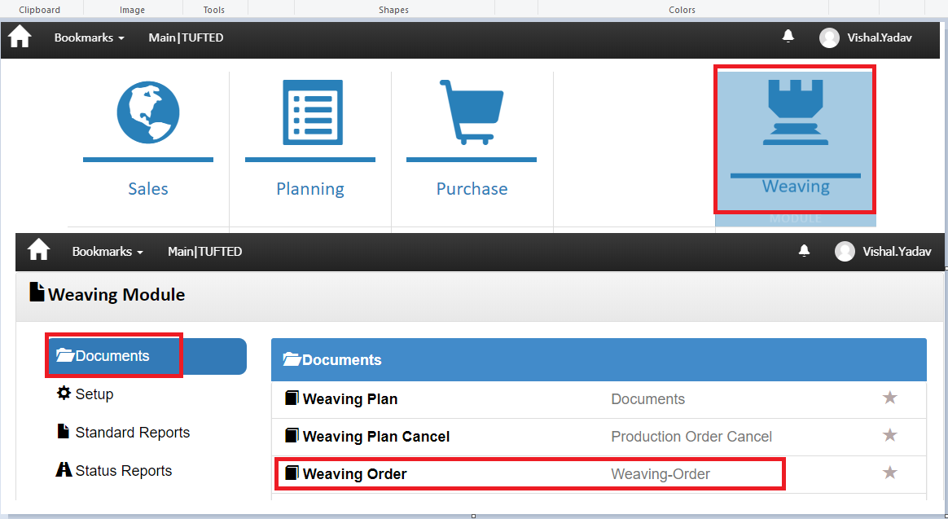

**In below Screen Shot mention all Document Types in which we update the due date.**

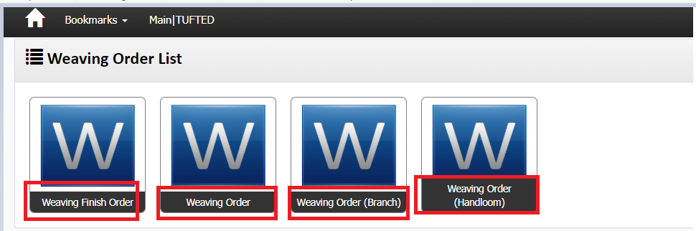

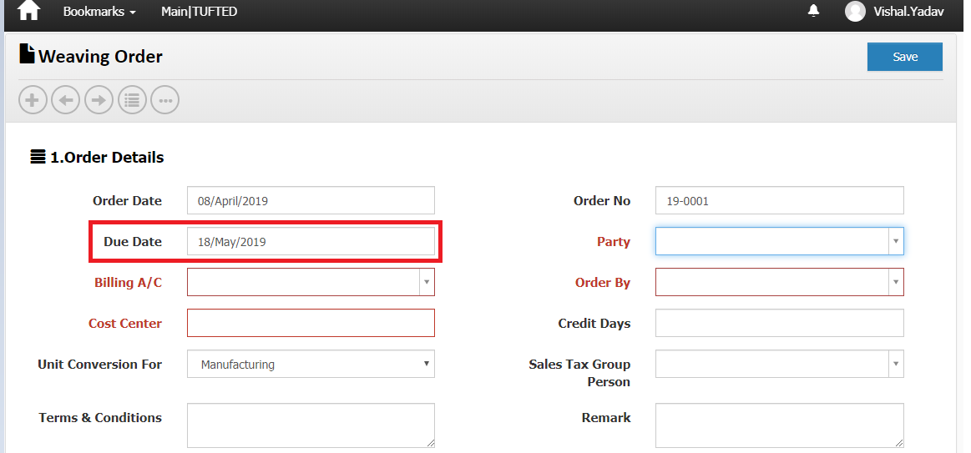

**The End**

*** Adjustment Carpet Physical stock Entry (old stock) In Sample Division (Manual Query) ***

**Why it process do?**

Basically In this process we adjust/maintain the previous year stock in sample division by writing database Query.

**How?**

Keep the final process of product of each division like Kelim (Safai), knotted (clipping Embossing) and tufted (Third Backing) with Lot No. wise

At time of closing Count the Pieces of Product with lot wise and each and every product have bar code

For Example: Suppose we have Lot No. A. Lot No. A keep 20 pcs of product and each and every product have bar code. i.e. 20 bar code

**Important Point: To Adjustment sample division stock get previous year record from user.**

**Find the Record as given below query for adjustment in next year.**

**SELECT * FROM Web.StockHeaders WHERE DocTypeId = 29 AND DivisionId = 6**

**AND DocNo IN (**

**'17-0458',**

**'17-0459',**

**'17-0457',**

**'17-0463',**

**'17-0453',**

**'17-0454',**

**'17-0451',**

**'17-0443',**

**'17-0439',**

**'17-0434',**

**'17-0445',**

**'17-0450',**

**'17-0447',**

**'17-0460',**

**'17-0608',**

**'17-0633',**

**'17-0644',**

**'17-0597',**

**'17-0621',**

**'17-0651',**

**'17-0664',**

**'17-0631',**

**'17-0676',**

**'17-0672',**

**'17-0659',**

**'17-0648',**

**'17-0671',**

**'17-0723',**

**'17-0689',**

**'17-0702',**

**'17-0715',**

**'17-0711',**

**'17-0725',**

**'17-0721',**

**'17-0707',**

**'17-0741',**

**'17-0700',**

**'17-0762',**

**'17-1116',**

**'17-1117',**

**'17-1123',**

**'17-1125',**

**'17-1127',**

**'17-1128',**

**'17-1131',**

**'17-1132',**

**'17-1133',**

**'17-1135',**

**'17-1136',**

**'17-1137',**

**'17-1138',**

**'17-1139',**

**'17-1140',**

**'17-1141',**

**'17-1142',**

**'17-1143',**

**'17-1144',**

**'17-1145',**

**'17-1146',**

**'17-1147',**

**'17-1148',**

**'17-1149',**

**'17-1152',**

**'17-1153',**

**'17-1154'**

**)**

**UNION ALL**

**SELECT * FROM Web.StockHeaders WHERE DocTypeId = 29 AND DivisionId = 1**

**AND DocNo IN (**

**'17-281',**

**'17-282',**

**'17-284',**

**'17-286',**

**'17-287',**

**'17-288',**

**'17-289',**

**'17-290',**

**'17-291',**

**'17-292',**

**'17-294',**

**'17-297',**

**'17-298',**

**'17-299',**

**'17-303',**

**'17-305',**

**'17-307',**

**'17-309',**

**'17-314',**

**'17-319',**

**'17-336',**

**'17-295'**

**)**

**UNION ALL**

**SELECT * FROM Web.StockHeaders WHERE DocTypeId = 29 AND DivisionId = 2**

**AND DocNo IN (**

**'17-172',**

**'17-176',**

**'17-180',**

**'17-182',**

**'17-191',**

**'17-211'**

**)**

**From above query get record as given below screen shot.**

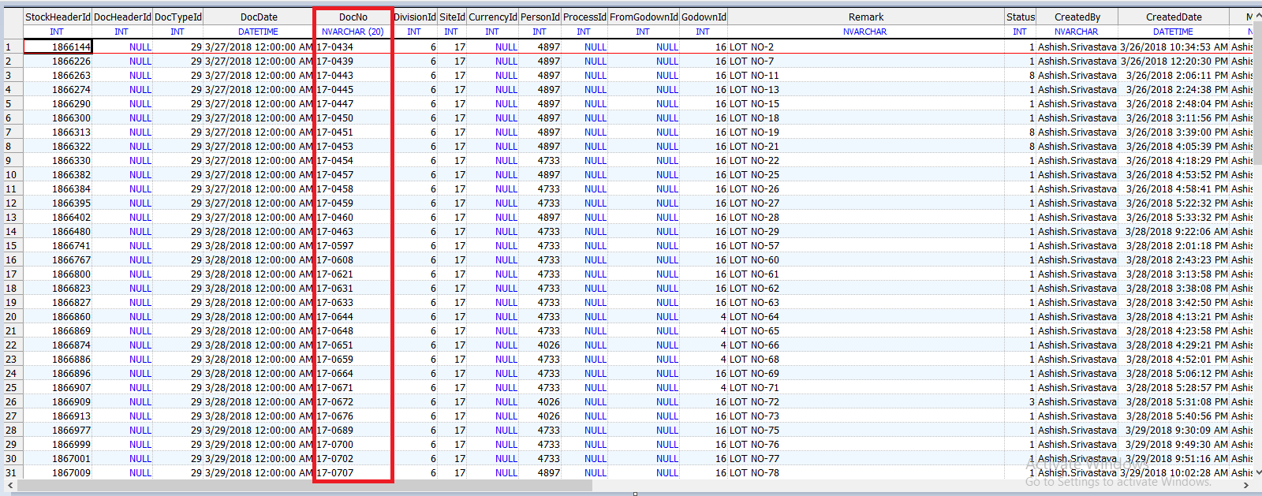

Getting StockheaderId from above query we insert record with “Added OL suffix in Doc No.” and extended the Doc Date.

First of Insert in Stock Headers table:

INSERT INTO Web.StockHeaders (DocTypeId, DocDate, DocNo, DivisionId, SiteId, CurrencyId, PersonId, ProcessId, FromGodownId, GodownId, Remark, Status, CreatedBy, CreatedDate, ModifiedBy, ModifiedDate,

OMSId, CostCenterId, MachineId, GatePassHeaderId, LedgerHeaderId, ContraLedgerAccountId, ReferenceDocTypeId, ReferenceDocId, LockReason, LedgerAccountId, ReviewCount, ReviewBy, IsGatePassPrinted)

SELECT H.DocTypeId, dateadd(YEAR,1,H.DocDate) AS DocDate, 'OL-' + H.DocNo, H.DivisionId, H.SiteId, H.CurrencyId, H.PersonId, H.ProcessId, H.FromGodownId, H.GodownId, H.Remark, H.Status, H.CreatedBy, H.CreatedDate, H.ModifiedBy, H.ModifiedDate,

H.StockHeaderId AS OMSId, H.CostCenterId, H.MachineId, H.GatePassHeaderId, H.LedgerHeaderId, H.ContraLedgerAccountId,

NULL AS ReferenceDocTypeId, NULL AS ReferenceDocId,

'Transfered From Last Year Data of Sample Department By IT Team' AS LockReason, H.LedgerAccountId, H.ReviewCount, H.ReviewBy, H.IsGatePassPrinted

FROM Web.StockHeaders H

WHERE H.DocTypeId = 29

AND H.StockHeaderId IN (1866144, 1866226, 1866263, 1866274, 1866290, 1866300, 1866313, 1866322, 1866330, 1866382, 1866384, 1866395, 1866402, 1866480, 1866741, 1866767, 1866800, 1866823, 1866827, 1866860, 1866869, 1866874, 1866886, 1866896, 1866907, 1866909, 1866913, 1866977, 1866999, 1867001, 1867009, 1867015, 1867020, 1867027, 1867030, 1867033, 1867062, 1867111, 1869534, 1869535, 1869541, 1869543, 1869545, 1869546, 1869549, 1869550, 1869551, 1869553, 1869554, 1869555, 1869556, 1869557, 1869558, 1869559, 1869560, 1869561, 1869562, 1869563, 1869564, 1869565, 1869566, 1869567, 1869570, 1869571, 1869572, 1869514, 1869515, 1869517, 1869519, 1869520, 1869521, 1869522, 1869523, 1869524, 1869525, 1869527, 1869528, 1869530, 1869531, 1869532, 1869536, 1869538, 1869540, 1869542, 1869547, 1869552, 1869569, 1869529, 1869533, 1869537, 1869539, 1869548, 1869568)

After That Insert Stock Lines table

INSERT INTO Web.StockLines (StockHeaderId, ProductUidId, RequisitionLineId, ProductId, FromProcessId, LotNo, Qty, Remark, Dimension1Id, Dimension2Id, Specification, Rate, Amount, CreatedBy, ModifiedBy, CreatedDate, ModifiedDate, OMSId, DocProductId, DocDimension1, DocDimension2, FromStockId, StockId, StockProcessHeader_StockProcessHeaderId, StockProcessId, CostCenterId, DocNature, ReferenceDocTypeId, ReferenceDocId, ReferenceDocLineId, LockReason, FromStockProcessid, Sr, ProductUidLastTransactionDocId, ProductUidLastTransactionDocNo, ProductUidLastTransactionDocTypeId, ProductUidLastTransactionDocDate, ProductUidLastTransactionPersonId, ProductUidCurrentGodownId, ProductUidCurrentProcessId, ProductUidStatus, Weight, Dimension3Id, Dimension4Id, StockInId)

SELECT Sh.StockHeaderId, L.ProductUidId, L.RequisitionLineId, L.ProductId, L.FromProcessId, L.LotNo, L.Qty, L.Remark, L.Dimension1Id, L.Dimension2Id, L.Specification, L.Rate, L.Amount, L.CreatedBy, L.ModifiedBy, L.CreatedDate, L.ModifiedDate, L.OMSId, L.DocProductId, L.DocDimension1, L.DocDimension2, L.FromStockId, L.StockId, L.StockProcessHeader_StockProcessHeaderId, L.StockProcessId, L.CostCenterId, L.DocNature, L.ReferenceDocTypeId, L.ReferenceDocId, L.ReferenceDocLineId,

'Transfered From Last Year Data of Sample Department By IT Team' AS LockReason, L.FromStockProcessid, L.Sr, L.ProductUidLastTransactionDocId, L.ProductUidLastTransactionDocNo, L.ProductUidLastTransactionDocTypeId, L.ProductUidLastTransactionDocDate, L.ProductUidLastTransactionPersonId, L.ProductUidCurrentGodownId, L.ProductUidCurrentProcessId, L.ProductUidStatus, L.Weight, L.Dimension3Id, L.Dimension4Id, L.StockInId

FROM Web.StockHeaders H

LEFT JOIN Web.StockHeaders Sh ON Convert(NVARCHAR,H.StockHeaderId) = Convert(NVARCHAR,Sh.OMSId)

LEFT JOIN Web.StockLines L ON H.StockHeaderId = L.StockHeaderId

WHERE H.DocTypeId = 29

AND H.StockHeaderId IN (1866144, 1866226, 1866263, 1866274, 1866290, 1866300, 1866313, 1866322, 1866330, 1866382, 1866384, 1866395, 1866402, 1866480, 1866741, 1866767, 1866800, 1866823, 1866827, 1866860, 1866869, 1866874, 1866886, 1866896, 1866907, 1866909, 1866913, 1866977, 1866999, 1867001, 1867009, 1867015, 1867020, 1867027, 1867030, 1867033, 1867062, 1867111, 1869534, 1869535, 1869541, 1869543, 1869545, 1869546, 1869549, 1869550, 1869551, 1869553, 1869554, 1869555, 1869556, 1869557, 1869558, 1869559, 1869560, 1869561, 1869562, 1869563, 1869564, 1869565, 1869566, 1869567, 1869570, 1869571, 1869572, 1869514, 1869515, 1869517, 1869519, 1869520, 1869521, 1869522, 1869523, 1869524, 1869525, 1869527, 1869528, 1869530, 1869531, 1869532, 1869536, 1869538, 1869540, 1869542, 1869547, 1869552, 1869569, 1869529, 1869533, 1869537, 1869539, 1869548, 1869568)

|  |  |  |
| --- | --- | --- |
| Sr No. | Table Name | Description |
| 1 | Web.StockHeaders | Already define in Closing tool document |
| 2 | Web.StockLines | Already define in Closing tool document |
|  |  |  |

**Out Put Screen shot:**

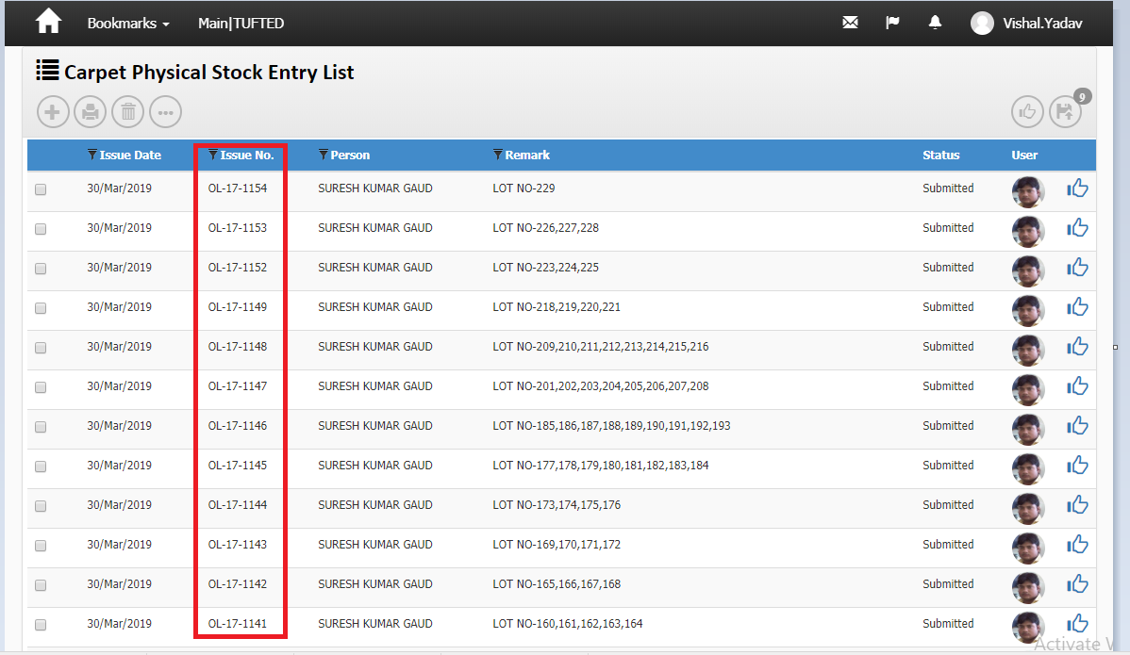

**The End**

** Carpet/Yarn/Other Material Adjustment (Manual Query) **

**Why it process Do?**

Basically carpet, yarn and other material keeps in godown. These material feed in application godown wise. At time of job order it do the issue and receive.

Finally at time of closing each and every godown match with physical and application report.

**How to match?**

Balance of godown wise stock of previous year it become the opening balance of next financial year.

Carpet, Yarn and Other material Adjustment process done by “Web.sp_StockAdjustment” stored procedure with godown wise.

List of document in which we perform adjustment with godown wise



**Procedure Description:**

ALTER PROCEDURE Web.sp_StockAdjustment (@DocTypeId INT, @DocDate SMALLDATETIME, @GodownId INT,

@CreatedBy NVARCHAR(Max), @DivisionId INT, @SiteId INT, @PhysicalDateList NVARCHAR(Max), @Remark NVARCHAR(Max))

AS

DECLARE @ProductTypeIds NVARCHAR(Max)

DECLARE @ContraDocTypeIds NVARCHAR(Max)

SELECT @ProductTypeIds = filterProductTypes, @ContraDocTypeIds = filterContraDocTypes

FROM Web.StockHeaderSettings WHERE DocTypeId = @DocTypeId AND SiteId = @SiteId AND DivisionId = @DivisionId

SET @CreatedBy = 'System'

DECLARE @ErrorTable AS TABLE

(

ErrorText NVARCHAR(Max)

)

IF (@ProductTypeIds = NULL OR @ProductTypeIds = '')

BEGIN

RETURN

END

DECLARE @DocNo NVARCHAR(20)

EXEC Web.FGetDocNo @DocDate, @DocTypeId, @SiteId ,@DivisionId,'Web.StockHeaders', @DocNo OUTPUT

BEGIN TRY

BEGIN TRANSACTION;

INSERT INTO Web.StockHeaders (DocTypeId, DocDate, DocNo, DivisionId, SiteId, GodownId, Remark, Status,

CreatedBy, CreatedDate, ModifiedBy, ModifiedDate)

SELECT @DocTypeId AS DocTypeId, @DocDate AS DocDate, @DocNo AS DocNo, @DivisionId AS DivisionId,

@SiteId AS Siteid, @GodownId AS GodownId, @Remark AS Remark, 1 AS Status, @CreatedBy AS CreatedBy, getdate() AS CreatedDate,

@CreatedBy AS ModifiedBy, getdate() AS ModifiedDate

DECLARE @StockHeaderId INT

--SELECT @StockHeaderId = StockHeaderId FROM inserted

SELECT @StockHeaderId = SCOPE_IDENTITY();

INSERT INTO Web.Stocks (StockHeaderId, ProductId, ProcessId, GodownId, Qty_Iss, Qty_Rec,

Dimension1Id, Dimension2Id, CreatedBy, ModifiedBy, CreatedDate, ModifiedDate, DocDate)

SELECT @StockHeaderId AS StockHeaderId, L.ProductId, L.ProcessId, @GodownId AS GodownId,

Case When IsNull(Sum(L.Qty_Rec),0) - IsNull(Sum(L.Qty_Iss),0) > 0 Then IsNull(Sum(L.Qty_Rec),0) - IsNull(Sum(L.Qty_Iss),0) Else 0 End As Qty_Iss,

Case When IsNull(Sum(L.Qty_Rec),0) - IsNull(Sum(L.Qty_Iss),0) < 0 Then IsNull(Sum(L.Qty_Iss),0) - IsNull(Sum(L.Qty_Rec),0) Else 0 End As Qty_Rec,

L.Dimension1Id, L.Dimension2Id,

@CreatedBy AS CreatedBy, @CreatedBy AS ModifiedBy,

getdate() AS CreatedDate, getdate() AS ModifiedDate,

@DocDate AS DocDate

FROM Web.Stocks L

LEFT JOIN Web.Products P ON L.ProductId = P.ProductId

LEFT JOIN Web.ProductGroups Pg ON P.ProductGroupId = Pg.ProductGroupId

WHERE L.GodownId = @GodownId

AND Pg.ProductTypeId IN (SELECT Items FROM [dbo].[Split] (@ProductTypeIds, ','))

AND L.DocDate <= @DocDate

GROUP BY L.ProductId, L.Dimension1Id, L.Dimension2Id, L.ProcessId

HAVING IsNull(Sum(L.Qty_Rec),0) - IsNull(Sum(L.Qty_Iss),0) <> 0

INSERT INTO Web.Stocks (StockHeaderId, ProductUidId, ProductId, ProcessId, GodownId, Qty_Iss, Qty_Rec,

Dimension1Id, Dimension2Id, CreatedBy, ModifiedBy, CreatedDate, ModifiedDate, DocDate)

SELECT @StockHeaderId AS StockHeaderId, L.ProductUidId, L.ProductId, L.FromProcessId AS ProcessId, @GodownId AS GodownId,

0 As Qty_Iss, Sum(L.Qty) As Qty_Rec,

L.Dimension1Id, L.Dimension2Id,

@CreatedBy AS CreatedBy, @CreatedBy AS ModifiedBy,

getdate() AS CreatedDate, getdate() AS ModifiedDate,

@DocDate AS DocDate

FROM Web.StockHeaders H

LEFT JOIN Web.StockLines L ON H.StockHeaderId = L.StockHeaderId

WHERE H.DocTypeId IN (SELECT Items FROM [dbo].[Split] (@ContraDocTypeIds, ','))

AND H.GodownId = @GodownId

AND H.DocDate IN (SELECT Convert(DATE,Items) FROM [dbo].[Split] (@PhysicalDateList, ','))

GROUP BY L.ProductUidId, L.ProductId, L.Dimension1Id, L.Dimension2Id, L.FromProcessId

INSERT INTO Web.StockLines(StockHeaderId, ProductUidId, ProductId, FromProcessId, Qty, Dimension1Id, Dimension2Id, Rate, Amount,

CreatedBy, ModifiedBy, CreatedDate, ModifiedDate, StockId, DocNature, Sr)

SELECT V1.StockHeaderId, V1.ProductUidId, V1.ProductId, V1.ProcessId AS FromProcessId, V1.Qty, V1.Dimension1Id, V1.Dimension2Id, 0 AS Rate, 0 AS Amount,

V1.CreatedBy, V1.ModifiedBy, V1.CreatedDate, V1.ModifiedDate, V1.StockId, V1.DocNature, Row_Number() OVER (ORDER BY V1.ProductId) AS Sr

FROM

(

SELECT L.StockHeaderId, L.ProductUidId, L.ProductId, L.ProcessId, L.Qty_Iss AS Qty, L.Dimension1Id, L.Dimension2Id,

L.CreatedBy, L.ModifiedBy, L.CreatedDate, L.ModifiedDate, L.StockId, 'I' AS DocNature

FROM Web.StockHeaders H

LEFT JOIN Web.Stocks L ON H.StockHeaderId = L.StockHeaderId

WHERE H.DocTypeId = @DocTypeId

AND IsNull(L.Qty_Iss,0) > 0

AND H.DocDate = @DocDate

UNION ALL

SELECT L.StockHeaderId, L.ProductUidId, L.ProductId, L.ProcessId AS FromProcessId, L.Qty_Rec AS Qty, L.Dimension1Id, L.Dimension2Id,

L.CreatedBy, L.ModifiedBy, L.CreatedDate, L.ModifiedDate, L.StockId, 'R' AS DocNature

FROM Web.StockHeaders H

LEFT JOIN Web.Stocks L ON H.StockHeaderId = L.StockHeaderId

WHERE H.DocTypeId = @DocTypeId

AND IsNull(L.Qty_Rec,0) > 0

AND H.DocDate = @DocDate

) AS V1

IF (@ProductTypeIds = '1')

BEGIN

UPDATE Web.ProductUids

SET Web.ProductUids.CurrenctGodownId = V1.GodownId,

Web.ProductUids.CurrenctProcessId = V1.ProcessId,

Web.ProductUids.Status = V1.Status

FROM (

SELECT L.ProductUidId, H.GodownId, L.ProcessId AS ProcessId, 'Receive' AS Status

FROM Web.StockHeaders H

LEFT JOIN Web.Stocks L ON H.StockHeaderId = L.StockHeaderId

LEFT JOIN Web.ProductUids Pu ON L.ProductUidId = Pu.ProductUIDId

WHERE H.DocTypeId = @DocTypeId

AND H.DocDate = @DocDate

AND L.ProductUidId IS NOT NULL

AND Pu.LastTransactionDocDate < @DocDate

) AS V1 WHERE Web.ProductUids.ProductUidId = V1.ProductUidId

UPDATE Web.ProductUids

SET Web.ProductUids.Status = VMain.Status

FROM (

SELECT Pu.ProductUIDId, 'NF' + FORMAT(COnvert(DATE,@DocDate), 'ddMMyy') AS Status

FROM Web.ProductUids Pu

LEFT JOIN (

SELECT L.ProductUidId, H.GodownId, L.FromProcessId AS ProcessId, 'Receive' AS Status

FROM Web.StockHeaders H

LEFT JOIN Web.StockLines L ON H.StockHeaderId = L.StockHeaderId

LEFT JOIN Web.ProductUids Pu ON L.ProductUidId = Pu.ProductUIDId

WHERE H.DocTypeId = @DocTypeId

AND H.DocDate = @DocDate

AND L.ProductUidId IS NOT NULL

) AS V1 ON Pu.ProductUIDId = V1.ProductUidId

WHERE V1.ProductUidId IS NULL

AND Pu.Status NOT IN ('Pack','Dispatch','Issue','Return','SILAI','Cancel','Gen')

AND Pu.Status NOT LIKE 'NF%'

AND Pu.LastTransactionDocDate < @DocDate

) AS VMain WHERE Web.ProductUids.ProductUidId = VMain.ProductUidId

END

UPDATE Web.StockHeaders

SET Web.StockHeaders.ReferenceDocId = V1.ReferenceDocId,

Web.StockHeaders.ReferenceDocTypeId = V1.ReferenceDocTypeId,

Web.StockHeaders.LockReason = 'Physical Stock Adjusted'

FROM (

SELECT H.StockHeaderId, @StockHeaderId AS ReferenceDocId, @DocTypeId AS ReferenceDocTypeId

FROM Web.StockHeaders H

WHERE H.DocTypeId IN (SELECT Items FROM [dbo].[Split] (@ContraDocTypeIds, ','))

AND H.GodownId = @GodownId

AND H.DocDate IN (SELECT Convert(DATE,Items) FROM [dbo].[Split] (@PhysicalDateList, ','))

) AS V1 WHERE Web.StockHeaders.StockHeaderId = V1.StockHeaderId

COMMIT TRANSACTION;

END TRY

BEGIN CATCH

ROLLBACK TRANSACTION

INSERT INTO @ErrorTable(ErrorText)

SELECT ERROR_MESSAGE() AS ErrorMessage;

END CATCH

SELECT * FROM @ErrorTable

GO

**Table Descriptions**

|  |  |  |
| --- | --- | --- |
| **Sr.No.** | **Table Name** | **Description** |
| 1 | Web.StockHeaderSettings | Keep information of stock headers setting related column like DocType id and etc. |
| 2 | Web.StockHeaders | Already define in closing tool app |
| 3 | Web. Stocks | Already define in closing tool app |
| 4 | Web. Products | Already define in closing tool app |
| 5 | Web.ProductGroups | Already define in closing tool app |
| 6 | Web.StockLines | Already define in closing tool app |
| 7 | Web.ProductUids | It holds the bar code information |

**How to run and Procedure Parameter descriptions:**

**For Carpet physical Stock Entry (29):**

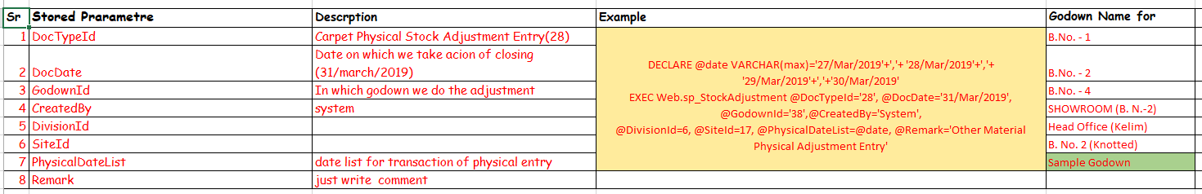

**For Yarn Physical stock Entry (491):**

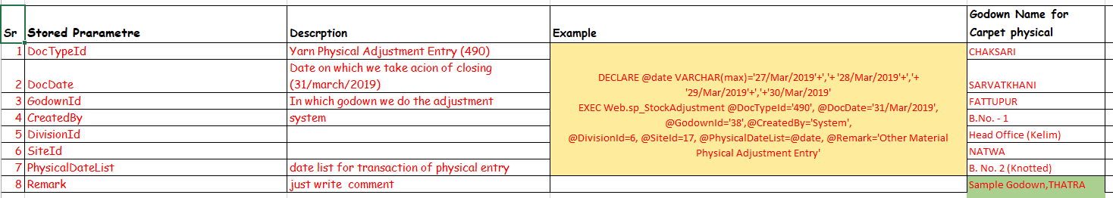

**For Other material Adjustment (225):**

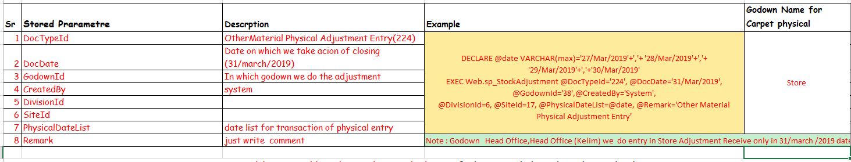

**Out Put Screen shot: First Report (Physical Stock summary)**

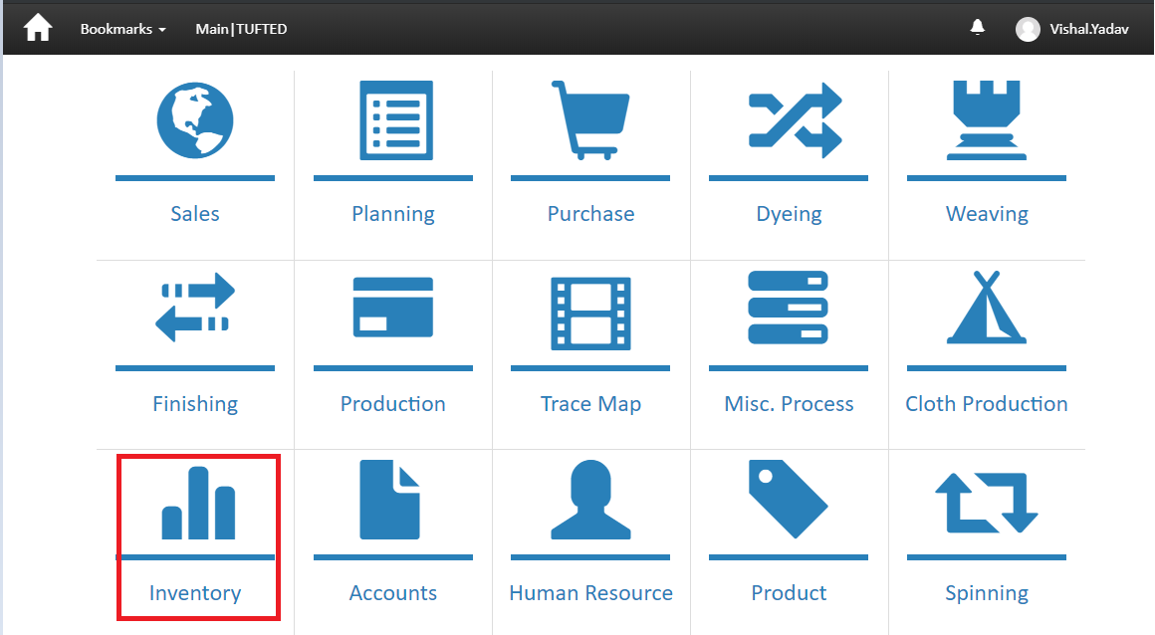

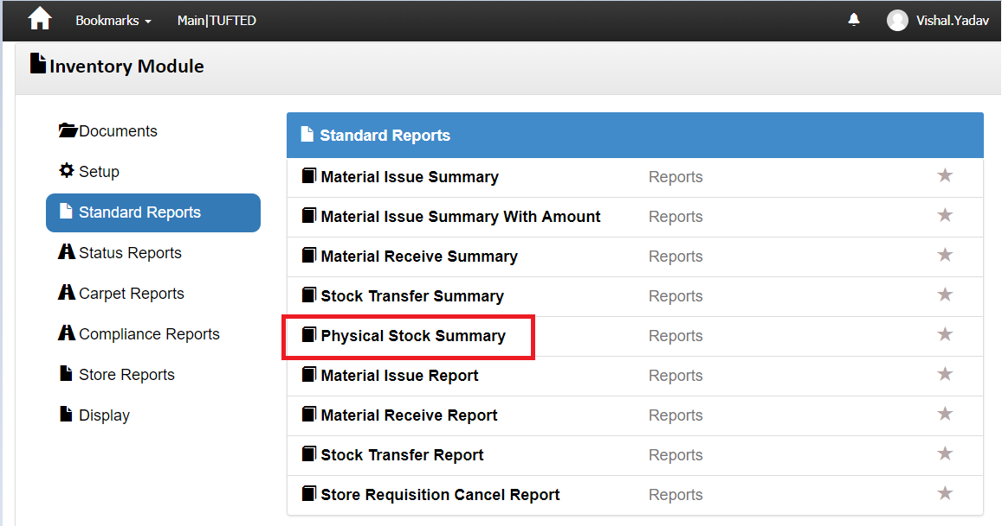

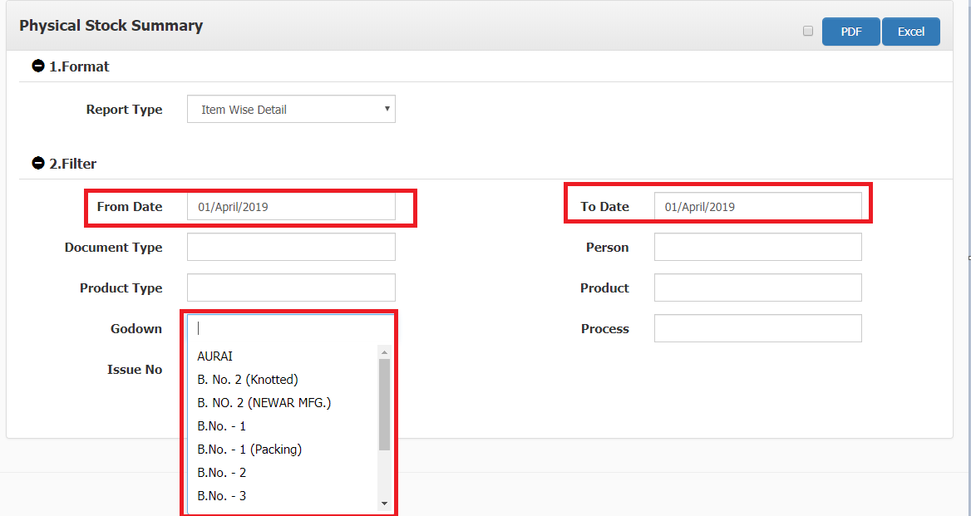

**Second Report (**[**Stock Reconciliation**](http://menu.suryacarpet.in/Menu/MenuSelection/1592)**)**

**For Yarn & Other material**

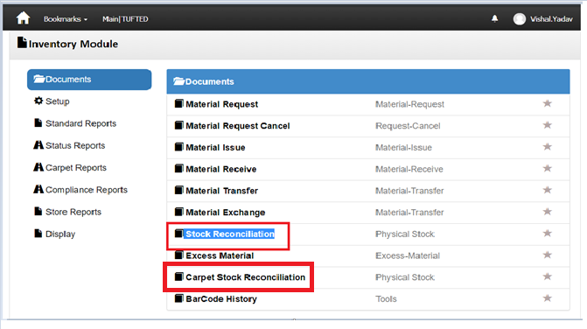

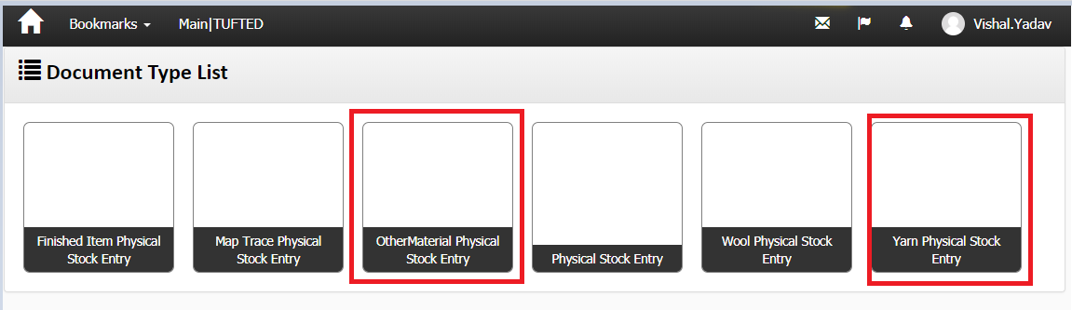

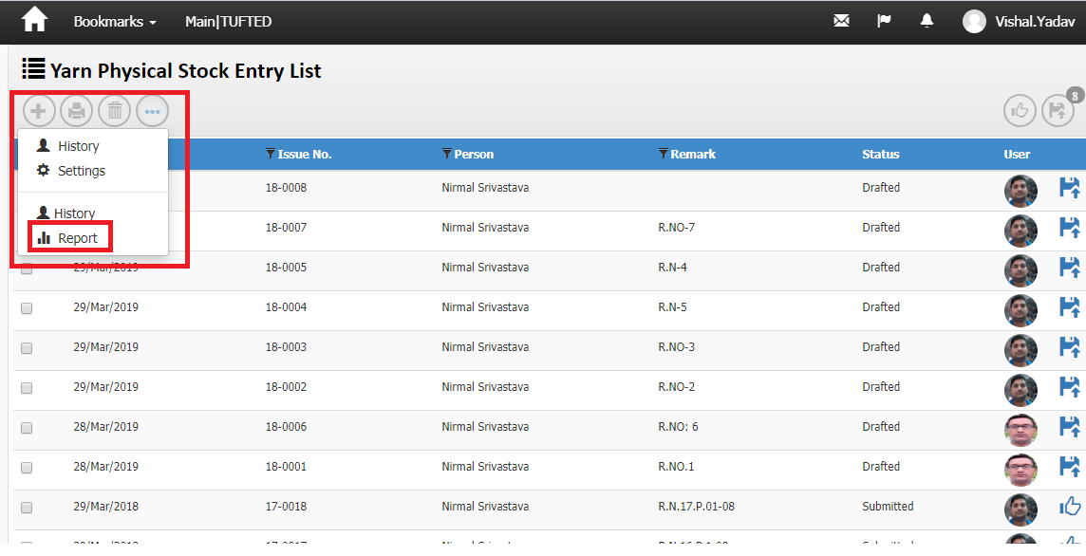

**Select product type rug for carpet and yarn for Yarn**

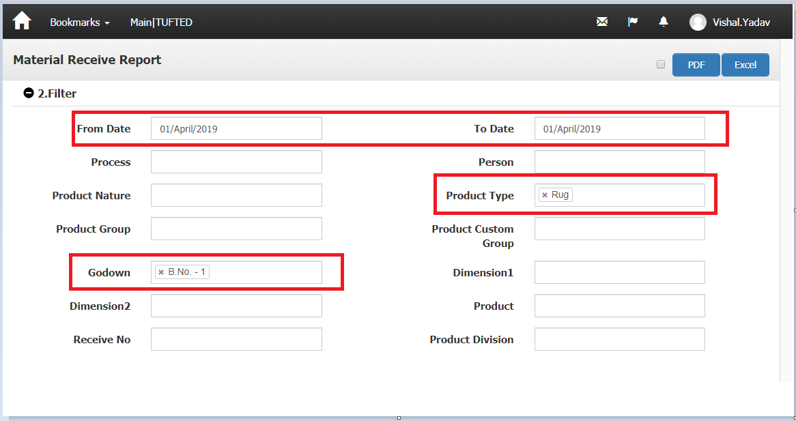

**For other material with store godown**

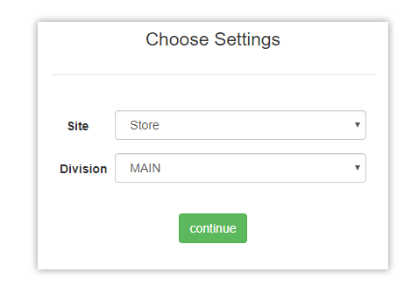

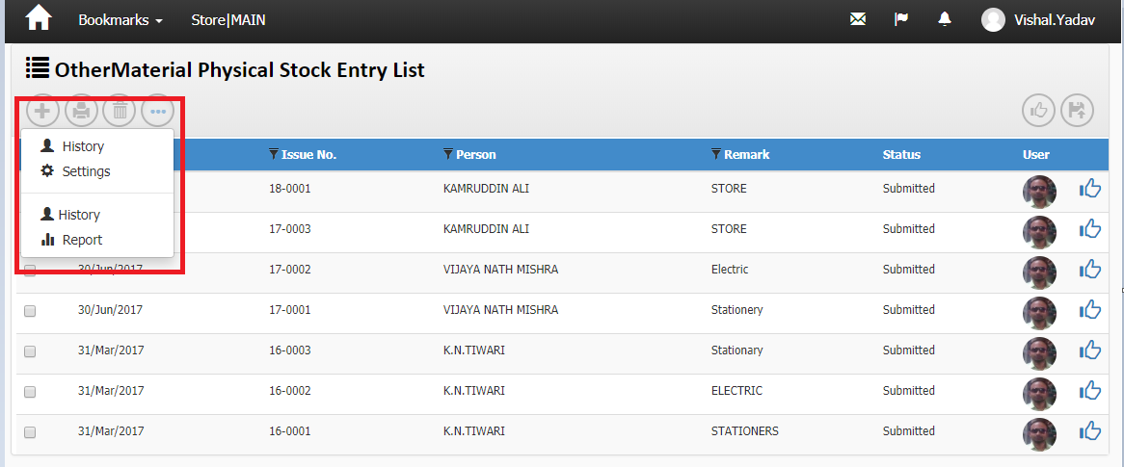

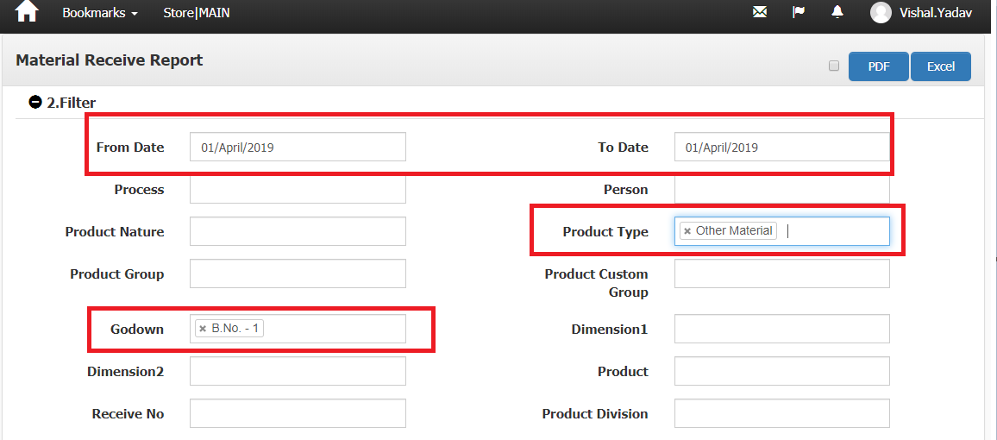

**The End**